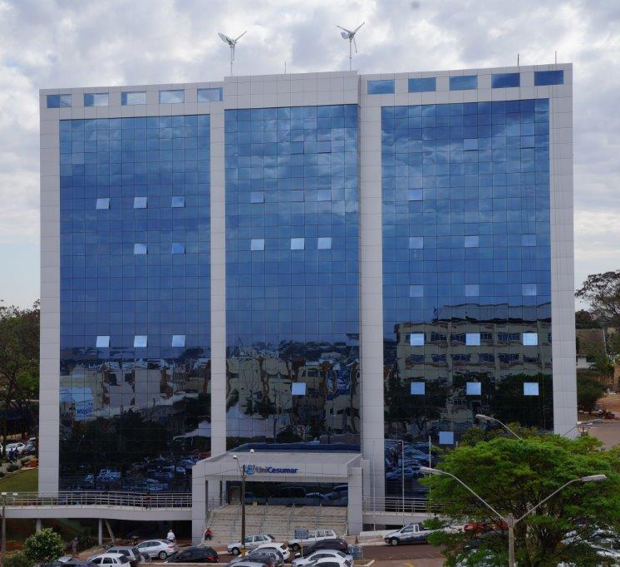

**Bloco 11**

**DATA BOOK**

|  |  |  |  |
| --- | --- | --- | --- |
| image001 | | | RELATÓRIO DE OBRA |
| Obra: | Centro Administrativo – Bloco 11 | | |
| Engº: | Marco Umberto Gino Sbardellati | | |
| Arquiteto: | | Helio Moreira Junior | |
| Período: 22/08/2014 a 24/11/2014 | | | |

|  |  |
| --- | --- |
| http://4.bp.blogspot.com/-_zBeQkZ6H9M/U9xBColuEGI/AAAAAAAAAHU/nwNd_YoWuFU/s1600/2014-08-01+08.08.25.jpg | Laje desenformada; |
|  |  |
| http://2.bp.blogspot.com/-wG2A26wnCSY/U9xBHHHd8tI/AAAAAAAAAHc/KCF2S3wCYlw/s1600/2014-08-01+08.46.18.jpg | Grande vão devido à laje nervurada; |
|  |  |
| http://4.bp.blogspot.com/-kjOZddlvsDE/U9xFr0yLBRI/AAAAAAAAAII/FHhDM8y-AQM/s1600/2014-08-01+08.03.46.jpg | Instalação da vedação - Vista exterior; |
|  |  |
| http://4.bp.blogspot.com/-yyl1tXBdvjw/U9xFlCWIdVI/AAAAAAAAAIA/ShmW5roUXM4/s1600/2014-08-01+08.23.43.jpg | Instalação da vedação - Vista interior; |
|  |  |
| http://4.bp.blogspot.com/-kO8Ej2ybmUI/U9xFv8bdokI/AAAAAAAAAIQ/ifXjtk2Se-s/s1600/IMG-20140801-WA0014.jpg | Guincho aranha utilizado para a suspensão das placas da vedação; |
|  |  |
| http://1.bp.blogspot.com/-3WIkpTaeJ50/U9xFemNyFVI/AAAAAAAAAH4/2aHqtI5xviI/s1600/IMG-20140801-WA0009.jpg | Detalhes da fixação das placas; |
|  |  |
| http://1.bp.blogspot.com/-QECcC5AKlPw/U9xFZOod0KI/AAAAAAAAAHw/7be82PaSXaA/s1600/IMG-20140801-WA0074.jpg | Instalação das placas; |
|  |  |
| http://1.bp.blogspot.com/-f9-wp2j4KMw/U9xGbwjOD5I/AAAAAAAAAIY/myCYk7lUn8U/s1600/2014-08-01+08.19.35.jpg | Fixação das placas no piso; |
|  |  |
| http://3.bp.blogspot.com/-OHUQ3sUkMb4/U9xIueqsS0I/AAAAAAAAAIk/pDzEndYg68s/s1600/IMG-20140801-WA0055.jpg | Piso do subsolo concretado parcialmente; |
|  |  |
| http://1.bp.blogspot.com/-VB00XMy9hpQ/U9xJAJ3dOFI/AAAAAAAAAI0/zO_xIoltokA/s1600/IMG-20140801-WA0063.jpg | Subsolo; |
|  |  |